Name of the Student: G. Manasa | Academic Year: 2025-26
Student Registration Number: 241U1R3007 | Year & Term: II & I
Study Level: UG | Class & Section: CSE(AI&ML)-2A
Name of the Course: PYTHON PROGRAMMING | Name of the Instructor: Mr. Pranay Vemula, Assistant Professor, CSE.
Name of the Assessment: Reflective Essay | Date of Submission:

PYTHON PROGRAMMING
REFLECTIVE ESSAY
Module-1: Python Basics, Operators and Expressions

Introduction
Python is a programming language. It was created by Guido van Rossum in the 1990s in the Netherlands. The name “Python” was taken from a comedy show called Monty Python, not from the snake. From the beginning, Python was free and open for everyone to use.
Google also started using Python in its early days, which made it very popular. At first, people thought Python was a small language. But later, it grew into a powerful and widely used language. Today, Python is used in making websites, mobile apps, data science, artificial intelligence, machine learning, and many other fields.


Installing Editors (IDEs and Text Editors)
Python works on Windows, Linux, and Mac.But sometimes the version is old. So, we download the new version from python.org.
There are many options, but some of the most popular ones are:
- IDLE: Comes built-in with Python. It is simple and good for beginners.
- PyCharm: A powerful IDE with many features for professional development.
- VS Code (Visual Studio Code): Lightweight, user-friendly, and highly customizable with extensions.
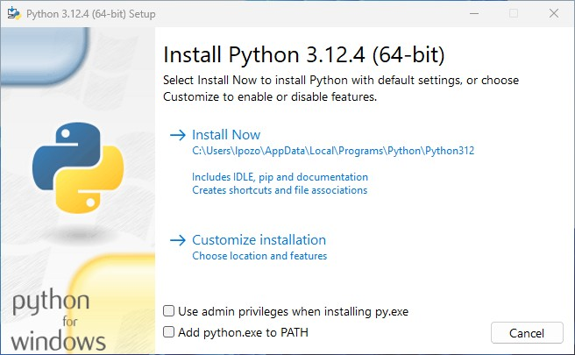
Variables, and Identifiers
A variable is like a container that stores data in memory. It gives a name to a value so we can use it later in the program.
Example:
x = 10
name = "Ravi"
pi = 3.14
Here, x, name, and pi are variables storing an integer, a string, and a float.
- They can store different types of data (integers, strings, floats, booleans, etc.).
- Their values can be changed during the program.
- They make programs more readable by using meaningful names.
Data Types
A data type tells the computer what kind of value a variable is storing.
- Numbers
a = 5 # Integer (whole number)
b = 3.14 # Float (decimal number)
c = 2 + 3j # Complex number
- String (text)
name = "python"
- Boolean (True or False)
flag = True
- List (a changeable collection)
marks = [90, 80, 70]
- Tuple (an unchangeable collection)
student = ("sathwik", 19)
- Set (collection of unique items)
s = {1, 2, 3}
- Dictionary (key–value pairs)
student = {"name": "sathwik", "age": 19}

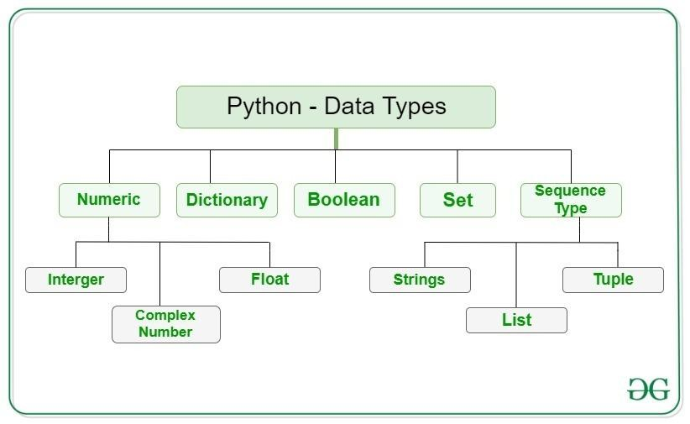
For example:
marks = [85, 90, 95]
student = ("Ravi", 20)
info = {"name": "Ravi", "age": 20}

Input and Output
- Use input() to take input from the user.
- Use print() to display output.
- All input is taken as string, so use int() or float() to convert it.
Example:
name = input("Enter your name: ")
print("Hello", name)
Comments
- Comments are notes in the program that Python ignores.
- They help us and others understand the code.
Types:
- Single-line comment → starts with #
- Multi-line comment → written inside triple quotes ''' ''' or """ """

Key Words
- Key words are Reserved words in Python that have special meaning.
- We cannot use them as identifiers (variable names, function names, etc.).
Examples of keywords:
if, else, while, for, class, def, return, break, continue, True, False, None, etc.
Indentation and Operators
Indentation means giving spaces at the beginning of a line. In many programming languages like C or Java, curly braces {} are used to define blocks. But in Python, indentation itself defines the block of code.
Example:
if True:
print("This line is indented")
print("It belongs to the if block")
print("This line is outside the if block")

Operators in Python
Operators are symbols that perform actions on values or variables.
Arithmetic operators
Comparison / Relational Operators
Logical Operators
Assignment Operators
Bitwise Operators
Unary Operators
Membership Operators
Identity Operators
Arithmetic Operators:
Arithmetic operators are symbols used to perform basic mathematical calculations in Python, like addition, subtraction, multiplication, and division.
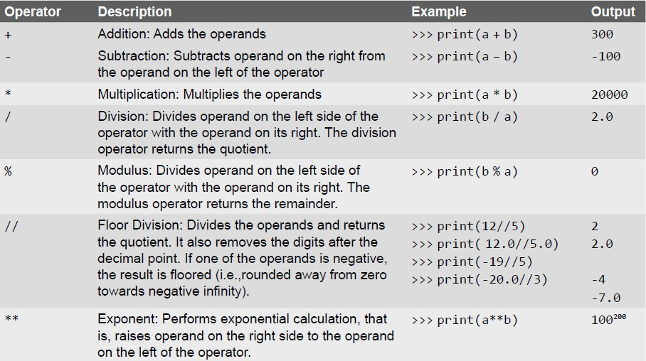
Used for basic math operations.
a = 10
b = 3
print(a + b) # Addition → 13
print(a - b) # Subtraction → 7
print(a * b) # Multiplication → 30
print(a / b) # Division → 3.33
print(a % b) # Modulus (remainder) → 1
print(a ** b) # Exponent (10³) → 1000
print(a // b) # Floor division → 3

Comparison / Relational Operators:
Comparison (or relational) operators are used to compare two values.
- The result of comparison is always a Boolean value → True or False.
- They are often used in decision-making (if statements, loops).
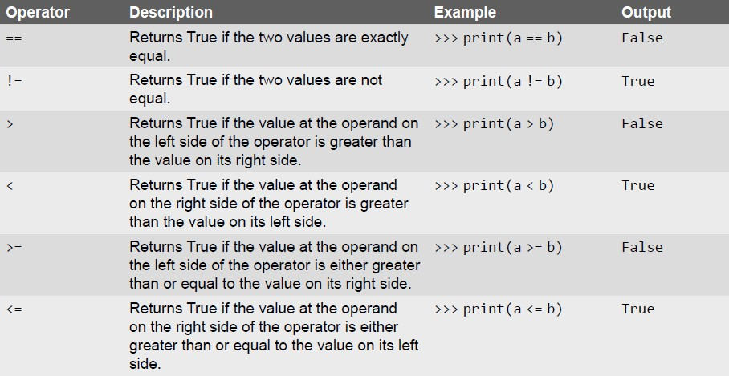

Logical Operators:

Logical operators return either True or False depending on the conditions. They are mainly used in if statements and loops to check multiple conditions at once.
Example:
a, b = 5, 10
print(a > 2 and b < 15)
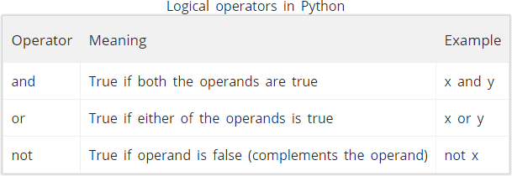

Assignment Operators:

Used to assign values and also update them.
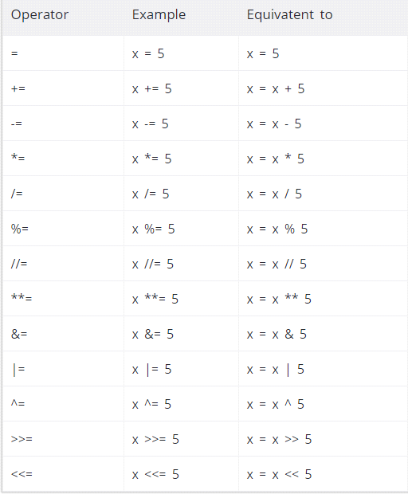

Bitwise Operators:
Work at the binary level (0s and 1s).
a = 5 # binary: 0101
b = 3 # binary: 0011

Operators | Description
& | Binary AND
| | Binary OR
^ | Binary XOR
~ | Binary Ones Complement
<< | Binary Left Shift
>> | Binary Right Shift

Unary Operators:
Work on a single operand.
x = 5
print(+x) # Unary plus → 5
print(-x) # Unary minus → -5
Membership and Identity Operators

Membership (in, not in) checks if an item exists in a collection.
Identity (is, is not) checks if two objects are the same in memory.

Expressions
An expression is any legal combination of symbols (like variables, constants and operators) that represents a value.
Example:

a = 10
b = 5

c = (a + b) * 2

Module-II
Selection/Conditional Branching Statements, Basic Loop Structures/Iterative Statements

Conditional Branching Statements
In programming, execution normally happens sequentially (line by line).
But sometimes, we want to make decisions and choose which block of code should run depending on conditions.
This is called Conditional Branching or Selection Statements.
Python provides the following conditional statements:
- if statement
- if–else statement
- nested if statement
- if–elif–else ladder
if Statement:
- Used when we want to execute a block of code only if the condition is true.
- If condition is false → nothing happens.
Example:
x = 10
if x > 5:
print("x is greater than 5")
Output:
x is greater than 5
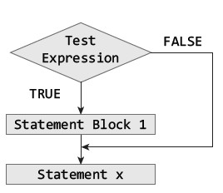

if–else Statement :
The if–else structure gave two paths: one for true and one for false. This made programs smarter. if marks >= 50: print("Pass")
else:
print("Fail")
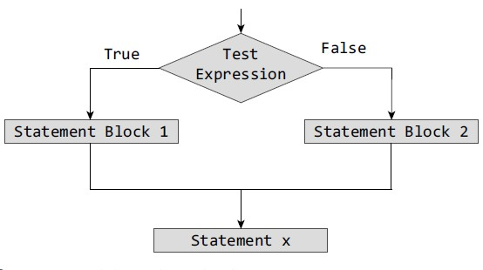

Nested if Statement :
The nested if statement allowed me to check multiple conditions inside each other. At first, it looked complicated, but it was useful for solving bigger problems.
Example: age = 20
if age >= 18: if age < 60:
print("Eligible for work")

Output:
Eligible for work

if–elif–else Statement :
This was very powerful. Instead of writing many nested ifs, the if–elif–else chain helped me check multiple conditions in a clean way. if marks >= 90:
print("Grade A")
elif marks >= 75: print("Grade B")
else:
print("Grade C")
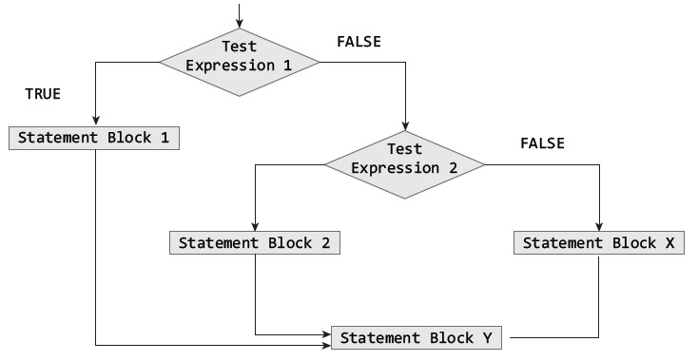

Looping Statements
while Loop :
The while loop kept running as long as a condition was true. I realized it is useful when we don’t know in advance how many times we need to repeat something.
count = 1
while count <= 5: print(count)
count += 1
for Loop :
The for loop was easier for repeating tasks when we know the range. It is very useful with lists and ranges. for i in range(1, 6):
print(i)
Nested Loops :
I also learned about nested loops, where one loop runs inside another. Though tricky at first, I saw how powerful they are, especially for patterns, tables, or multi-level data.
Example:
for i in range(1, 4): for j in range(1, 4): print(i, j)

Break Statement
The break statement stops a loop immediately. I realized it is helpful when we find what we are looking for and don’t need to continue.
Example:
for i in range(1,10): if i == 5:
break
print(i)

Continue Statement
The continue statement skips the current step and moves to the next. It made the loop flexible by ignoring certain conditions.

Example:
for i in range(1, 6): if i == 3: continue
print(i)

Pass Statement
The pass statement does nothing but acts like a placeholder. At first, it felt useless, but later I understood it helps when we are writing code structure but not ready with the full logic.
Example:
for i in range(5):
pass
Module-III
Introduction to Functions
Understanding Functions
Function is a block of organized code that performs a specific task. Functions reduce repetition because instead of writing the same logic again and again, we can write it once and call it whenever needed.
Python has two types of functions:

Built-in functions like print(), len(), input().

User-defined functions created by programmers using the def keyword.
Functions bring modularity to programs, meaning large tasks can be divided into smaller tasks.
Built-in Functions
Built-in functions in Python are the functions that are already provided by Python itself.
They are designed to perform common tasks like printing, taking input, finding length, type checking, mathematical operations, etc.

Examples of Built-in Functions
print() , input() , len() , type() , max() and min() , sum()
Commonly Used Built-in Functions
  - print() – Displays output on the screen. print("Hello, Python")

  - input() – Takes input from the user as a string.
name = input("Enter your name: ")
print("Welcome,", name)

  - len() – Returns the length of a string, list, or collection.
fruits = ["apple", "banana", "cherry"]
print(len(fruits))
Output: 3

  - type() – Shows the data type of a variable.
x = 10
print(type(x))
Output: <class 'int'>

  - max() and min() – Find the largest and smallest values.
numbers = [5, 8, 2, 10]
print(max(numbers))
print(min(numbers))

  - sum() – Adds all elements in a list or tuple.
marks = [50, 60, 70]
print(sum(marks))

  - range() – Generates a sequence of numbers, useful in loops.
for i in range(1, 6): print(i)

  - abs() – Returns the absolute (positive) value.
print(abs(-7))

  - round() – Rounds a number to the nearest integer or given decimal place.
print(round(3.14159, 2))
  - sorted() – Returns a sorted list.
nums = [4, 1, 3, 2]
print(sorted(nums))

User-defined functions
User-defined functions are the functions that we create ourselves in Python to perform specific tasks. Unlike built-in functions (which are already provided by Python), user-defined functions are written by programmers when they need to reuse some logic multiple times. They help make the program organized, reusable, and easy to understand.
Example:
Input:
def greet():
print("Hello, welcome to Python!")

greet()
Output:
Hello, welcome to Python!

Benefits of Functions
1. Code Reusability
- Functions let us write code once and use it many times.
- Example: If we write an add(a, b) function, we can use it in multiple programs without rewriting the logic.
- Code Simplification
- Large programs become easier to manage when divided into small functions.
- Each function performs a specific task, which makes the program clean and understandable.
- Easy Debugging and Testing
- If there is an error, we can test a single function separately instead of checking the whole program.
- This makes debugging easier and faster.
- Improved Readability
- Functions with proper names (like calculate_area() or is_prime()) make the program self-explanatory.
- Anyone reading the code can easily understand what it does.
- Teamwork and Collaboration
- In big projects, different programmers can work on different functions.
- Later, all functions can be combined into one program.
- Avoids Repetition
- Instead of writing the same set of statements multiple times, we can just call the function whenever required.
- This saves time and effort.
- Flexibility with Arguments and Return Values
- Functions can take inputs (parameters) and give back results (return).
- This makes them very flexible for solving a variety of problems.

Function Declaration and Definition Function:
A function in Python is a block of reusable code that performs a specific task. It helps make the program shorter, cleaner, and easier to understand.
Function Declaration
In some programming languages (like C or Java), functions are first declared (name, return type, and parameters are introduced) before being defined. In Python, we usually do not write a separate declaration. The declaration and definition happen together when we use the def keyword.

Function Definition
A function definition tells Python what the function should do. It includes the function name, parameters, body (statements), and an optional return statement.
Example 1: Function without Parameters
def greet():
print("Hello, welcome to Python!")
greet()
Output:
Hello, welcome to Python!
Example2 : Function with Parameters and Return
def add(a, b): return a + b
result = add(5, 3)
print(result)
Output:
8

Variable Scope and Lifetime Variable:
A variable is like a container or storage location in a program that holds some data (value). It is a name that refers to a value stored in the computer’s memory. Variables make it possible to store, update, and use data in programs.
Rules for Variables in Python
- A variable name can contain letters, digits, and underscores.
- It cannot start with a digit.
- Variable names are case-sensitive (Age and age are different).
- Keywords like if, while, class cannot be used as variable names.

Example:
x = 10
name = "Ravi"
pi = 3.14
is_active = True
print(x, name, pi, is_active)
Output:
10 Ravi 3.14 True

Types of Variables
- Local Variable – defined inside a function, used only there.
- Global Variable – defined outside functions, can be used anywhere in the program.
1.Local Variable
A local variable is a variable that is declared inside a function. It can be used only within that function. Its lifetime ends when the function finishes execution.
Example: def show(): x = 10
print("Inside function:", x)
show()
print(x)

2.Global Variable
A global variable is declared outside all functions. It can be used anywhere in the program, inside or outside functions. It exists for the entire lifetime of the program.
Example:
x = 50
def display():
print("Inside function:", x)
display()
print("Outside function:", x)
Output:
Inside function: 50
Outside function: 50
Return Statement
A return statement is used in a function to send a value back to the place where the function was called. If a function does not have a return statement, it automatically returns None. With return, a function can give results, expressions, or multiple values back to the caller.
Examples
- Function Returning a Value
def add(a, b): return a + b
result = add(5, 3)
print(result)
Output:
8
- Function Without Return
def greet(name):
print("Hello,", name)
result = greet("Ravi")
print(result)
Output:
Hello, Ravi
None
- Function Returning Multiple Values
def calculate(a, b): return a+b, a-b, a*b
x, y, z = calculate(10, 5)
print(x, y, z)
Output:
15 5 50
Types of Arguments
Positional Arguments
In positional arguments, the order of values matters. The first value goes to the first parameter, the second value to the second parameter, and so on.
Example:
def student_info(name, age): print("Name:", name)
print("Age:", age)
student_info("Ravi", 20)
Output:
Name: Ravi
Age: 20

Keyword Arguments
In keyword arguments, we use the parameter name while calling the function. The order does not matter because names are used to match values.
Example:
student_info(age=20, name="Ravi")
Output:
Name: Ravi
Age: 20

Default Arguments
In default arguments, a parameter has a default value. If no value is given while calling, Python uses the default.
Example:
def greet(name="User"): print("Hello,", name)
greet("Ravi")
greet()

Variable-Length Arguments
Sometimes we don’t know how many values will be passed. Python allows two ways:
*args → Positional variable-length arguments
Collects multiple values into a tuple.

def add(*nums):
print(sum(nums))
add(2, 3, 4)
add(5, 10)

**kwargs → Keyword variable-length arguments
Collects multiple keyword arguments into a dictionary.

def show_details(**info):
for key, value in info.items():
print(key, ":", value)
show_details(name="Ravi", age=20, city="Delhi")

Lambda Functions
A lambda is a short unnamed function, useful for small tasks.
Syntax:
lambda args: expression Examples:
square = lambda x: x * x
print(square(4)) # 16
# sort a list of tuples by second item
pairs = [(1, 'b'), (2, 'a')]
pairs.sort(key=lambda x: x[1])
Use cases: short callbacks for sorted, map, filter, or small one-line operations. For complex logic use def (named function) for readability.
Recursion
Recursion is when a function calls itself. Useful for problems that can be divided into smaller subproblems (like trees, factorial, quicksort).
Example — factorial:
def factorial(n): if n == 0:
return 1
return n * factorial(n - 1) # recursive case
Example
(inefficient):
def fib(n):
if n < 2:
return n
return fib(n-1) + fib(n-2)

Higher-Order Functions & First-Class Functions
In Python, functions are first-class you can pass them as arguments, return them, or store them in variables.
Example:
def apply(func, value): return func(value)
print(apply(lambda x: x+1, 5))
Module-IV
Features of Object-Oriented Programming

Introduction
In this module, I learned about Object-Oriented Programming (OOP), which is a style of programming that organizes code around objects rather than just functions. At first, the terms like classes, inheritance, polymorphism, abstraction looked difficult, but as I studied each one, I realized that OOP makes programs structured, reusable, and easier to manage. This module gave me a new way of thinking about solving problems in Python.
Classes and Objects
Class is like a blueprint, and an object is an actual thing created from that blueprint. A class defines properties (attributes) and behaviors (methods).
An object is an instance of the class.
Example:
class Student: def __init__(self, name, age):
self.name = name
self.age = age
s1 = Student("Ravi", 20)
print(s1.name)

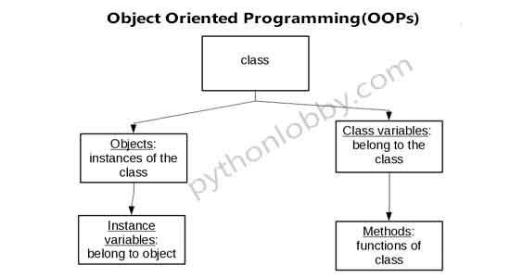

Methods and Message Passing
A method is a function inside a class that works with the object’s data. Message passing happens when an object calls these methods.
class Car:
def start(self):
print("Car started")
c1 = Car()
c1.start() # Message passing

Data Abstraction
Abstraction is the mechanism in which hiding internal details and showing functionality.
Data Encapsulation
Data Encapsulation is also called as data hiding
There are three access levels public, protected, private
Example:
class Student:
def __init__(self):
self.__marks = 0 # private variable
def set_marks(self, m): # setter method
if m >= 0:
self.__marks = m
def get_marks(self): # getter method
return self.__marks
# Create object
s = Student()
s.set_marks(85)
print(s.get_marks())

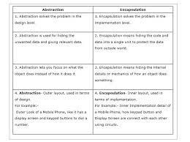
Polymorphism
polymorphism is nothing but many forms having same method name with different task.
Example:
class Animal:
def speak(self):
print("Animal speaks")
class Dog(Animal):
def speak(self):
print("Dog barks")
class Cat(Animal):
def speak(self):
print("Cat meows")
# Polymorphism in action
for animal in (Dog(), Cat()):
animal.speak()

Inheritance
Inheritance allows a new class to take properties and methods from an existing class. It promotes reusability. Child class can use or modify parent class features.
Example: class Animal: def sound(self):
print("Animal makes a sound")
class Dog(Animal): def sound(self):
print("Dog barks")
d = Dog()
d.sound()

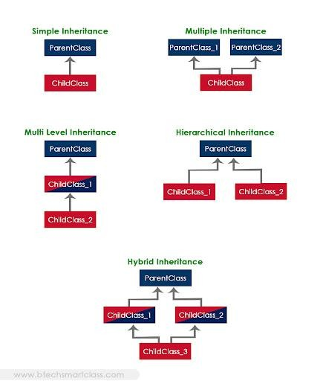

Types of inheritance:
1. Single Inheritance
One child class inherits from one parent class.
2. Multiple Inheritance
One child class inherits from more than one parent class.
3. Multilevel Inheritance
Class is derived from a class which is also derived from another class.
4. Hierarchical Inheritance
Multiple child class inherit from a single parent class.
5. Hybrid Inheritance
A mix of two or more types of inheritance.
Reusability
Reusability means using existing code.
Example:
class Animal:
def sound(self):
print("Some sound")
class Dog(Animal):
def bark(self):
print("Dog barks")
d = Dog()
d.sound()
d.bark()

Delegation
Delegation means an object hands over a task to another object instead of doing it itself.

Module-V
Data Structures: Sequence, Arrays, Vectors, Lists, Tuple, Sets, Dictionaries, Maps

Introduction
Data structures in Python, which are ways of storing and organizing data. At first, I thought data structures were only used in advanced programming, but soon I realized they are part of almost every program we write. They help manage data more effectively and make problem-solving faster. I studied different types of data structures like sequences, arrays, vectors, lists, tuples, sets, dictionaries, and maps.
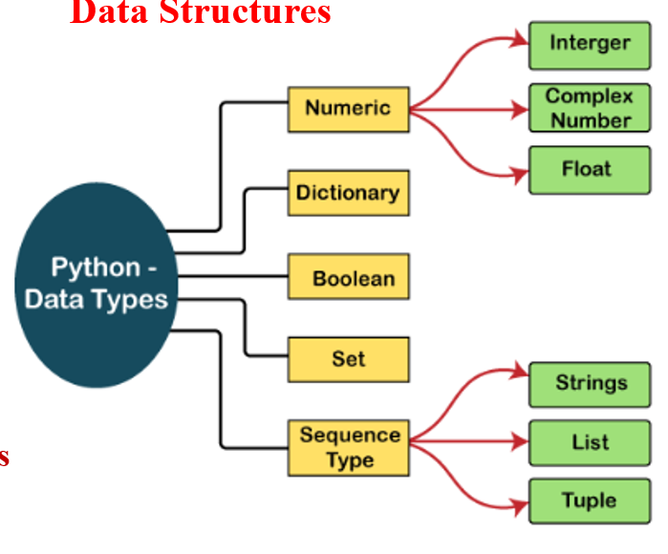

Sequence
A sequence is a general term for any ordered collection of elements in python like strings, lists, tuples
Example:
string_seq = "Hello"
list_seq = [1, 2, 3]
tuple_seq = (1, 2, 3)
range_seq = range(5)
Common Operations:
seq = [1, 2, 3, 4, 5]
print(len(seq)) # Length → 5
print(seq[0]) # Indexing → 1
print(seq[1:4]) # Slicing → [2, 3, 4]
print(seq + [6, 7]) # Concatenation → [1,2,3,4,5,6,7]
print(3 in seq) # Membership test → True

Arrays and Vectors
Arrays store multiple values of the same type efficiently. In Python, arrays can be used through the array module or NumPy library.
Vectors are similar to one-dimensional arrays and are very useful in mathematics, data science, and machine learning.
Example: import array
nums = array.array('i', [1, 2, 3, 4])
print(nums[1]) # 2
Common type codes:
- 'i' → integer
- 'f' → float
Common Operations:
import array
arr = array.array('i', [1, 2, 3])
arr.append(4) # Add element → array('i', [1, 2, 3, 4])
arr.insert(1, 10) # Insert at index → array('i', [1, 10, 2, 3, 4])
arr.pop(2) # Remove by index → removes element at index 2
arr.remove(10) # Remove by value → removes 10
arr[0] = 99 # Update element → array('i', [99, 2, 3, 4])
print(arr[1]) # Access → 2

Lists
A list is one of the most flexible data structures in Python. It is ordered, mutable, and can store different data types. We can add, remove, or update items easily.
Syntax:
my_list = [1, "apple", 3.14]
my_list.append("banana")
print(my_list[0])
Example:
fruits = ["apple", "banana", "cherry"]
fruits.append("mango")
print(fruits)

Tuples
A tuple is similar to a list but immutable (cannot be changed once created). Tuples are faster than lists. They are useful when data must remain fixed.
Syntax:
my_tuple = (1, "apple", 3.14)
print(my_tuple[1])
Example:
colors = ("red", "green", "blue")
print(colors[0]) # red

Sets
A set is an unordered collection that stores unique items. It removes duplicates automatically. It allows mathematical operations like union, intersection, and difference.
Syntax:
my_set = {1, 2, 3, 2}
my_set.add(4)
print(my_set)
Example:
a= {1, 2, 3}
b= {3, 4, 5}
print(a | b) # {1, 2, 3, 4, 5}
print(a & b) # {3}

Dictionaries
dictionaries store key value pairs Keys are unique, and values can be of any type. Dictionaries allow fast lookups.
Syntax:
my_dict = {"name": "Alice", "age": 25}
print(my_dict["name"])
my_dict["city"] = "New York"

Example:
student = {"name": "Ravi", "age": 20, "course": "Python"}
print(student["name"]) # Ravi

Maps
Map is a function to apply an operation to every element of a sequence
Syntax:
nums = [1, 2, 3]
squared = list(map(lambda x: x**2, nums))
print(squared)

Example:
nums = [1, 2, 3, 4]
squares = list(map(lambda x: x*x, nums))
print(squares) # [1, 4, 9, 16]

Module-VI
Strings and its operations:

Strings
A string is a sequence of characters enclosed in single quotes (' '), double quotes (" "), or triple quotes (''' ''' / """ """).
Examples:
s1 = 'Hello'
s2 = "World"
s3 = '''This is
a multi-line string'''
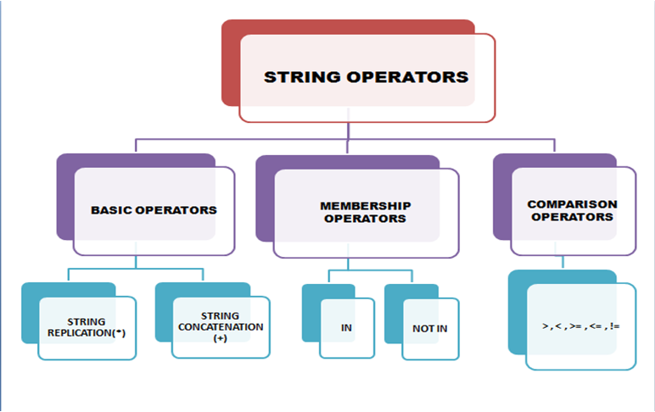

Mutable V/s Immutable Data Types
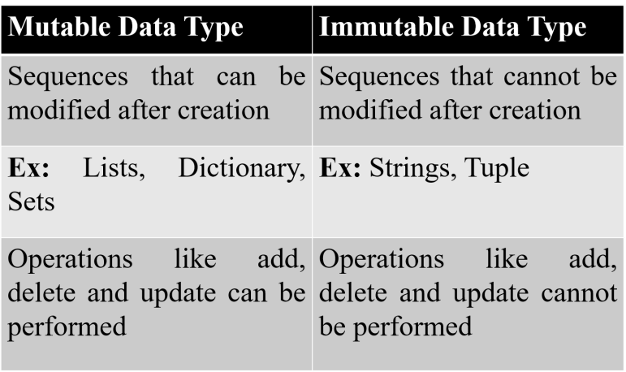

Basic String Operations
Concatenating
Joining of two or more strings into a single one is called concatenation. The + operator does this in Python.
Example:
a = "Hello"
b = "World"
c = a + " " + b
print(c) # Output: Hello World

Appending
Strings are immutable (cannot be changed in place), so “appending” means creating a new string by concatenation.
Example:
text = "Python"
text = text + " Programming"
print(text) # Output: Python Programming

Multiplying Strings
Use * to repeat a string multiple times.
Example:
word = "Hi "
print(word * 3) # Output: Hi Hi Hi

Built-in String Methods and Functions
Common Methods:
s = " Hello World "
print(s.lower())
print(s.upper())
print(s.strip())
print(s.replace
print(s.split())
print(s.find("World")
print(s.count("l"))
print(s.startswith("He"))
print(s.endswith("ld"))

Built-in Functions for Strings
len(s)
max(s)
min(s)
sorted(s)

Slice Operation
Used to extract part of a string using [start:end:step]
Examples:
word = "Python"
print(word[0:3]
print(word[:4])
print(word[2:])
print(word[-3:])
print(word[::-1])

Iterating Through a String
A string can be loope character by character using a for loop.
Example:
for char in "Hello":
print(char)

string Module

The string module contains useful constants and functions for string operations.

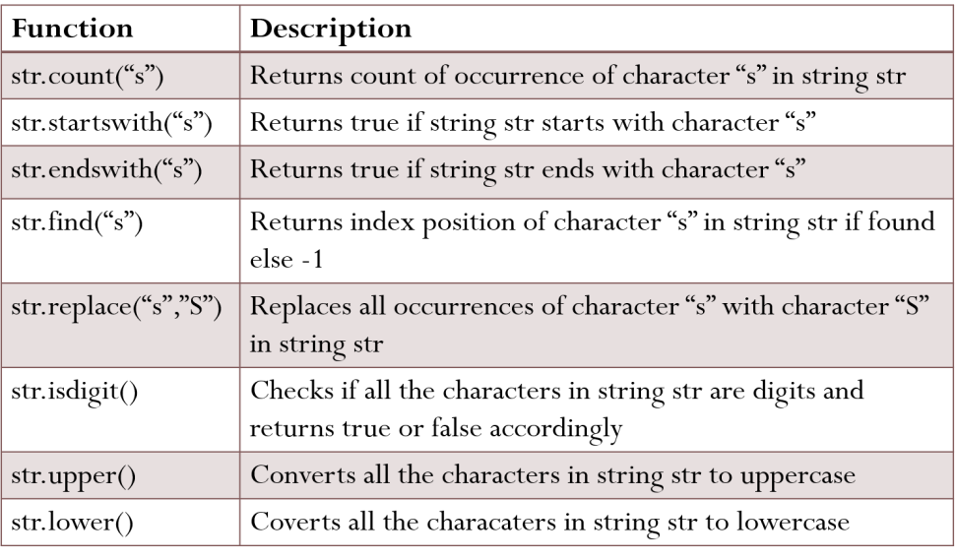
Example:
import string
print(string.digits)
print(string.punctuation)
This gave me more tools for text processing and validation.

Module-VII
Multithreading, Error and Exceptional Handling

Multi-threading allows a program to run multiple tasks at the same time, which improves efficiency.

Introduction to Thread
A thread is the smallest unit of execution within a program. Multiple threads can run concurrently in the same process, sharing memory and resources.
Example: import threading
def task():
print("Thread is running")
# Creating a thread
t = threading.Thread(target=task)
t.start()
t.join()
Advantages of a Thread
Threads are widely used because they provide many advantages:
- Improved Performance – Tasks run in parallel.
- Responsiveness – Programs don’t freeze during long tasks.
- Resource Sharing – Multiple threads share memory.
- Better CPU Utilization – Useful in multi-core systems.
- Simplified Program Design – Easier handling of tasks like multiple clients in a server.
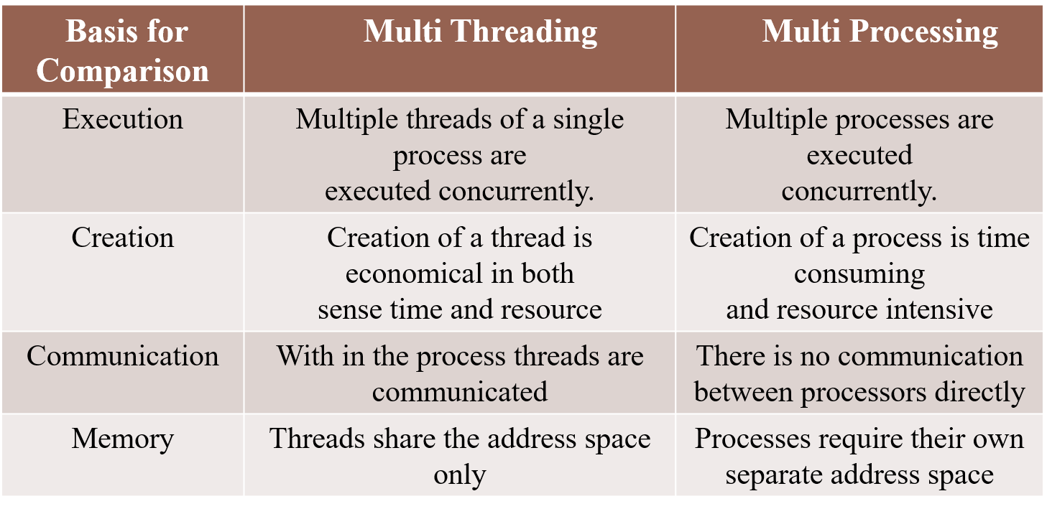

Thread life cycle
Newborn: when we create a thread object the thread is born.
Runnable state: it means the thread is ready for execution
Running state: it means the processor has given its time to the thread for execution.
Blocked state: A thread is said to be blocked
Dead state: a runnable thread enters the dead or terminated state when it complete its task.
Example:
import threading, tim
def worker(): print("Thread running...")
time.sleep(2)
print("Thread finished.")
t = threading.Thread(target=worker)
print("Thread created (New)")
t.start() # Runnable -> Running
print("Thread started")
t.join() # Waits until thread finishes
print("Thread terminated")

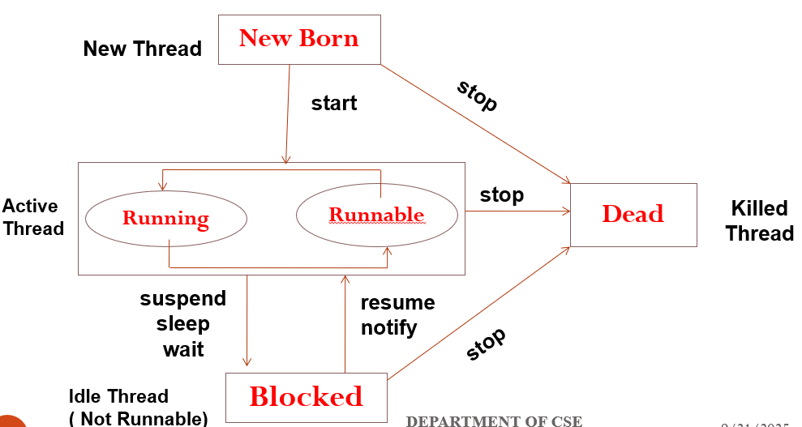

Threading module
Python provides the threading module, which makes it easy to create and control threads. Methods like start(), run(), join(), and isAlive() are essential in thread management.
Run(): this method is the entry point for thread
Start(): this method starts the execution of a thread by calling the run method
Join(): this method waits for thread to terminate
isAlive(): this method checks whether a thread is still executing
getName(): suggests a name it returns the name of a thread
setName(): this method is used to set name of thread
Example:
import threading
import time
def task():
time.sleep(1)
print(f"Running: {threading.current_thread().name}")
t = threading.Thread(target=task, name="MyThread")
t.start()
print("Is thread alive?", t.is_alive())
t.join()
print("Is thread alive after join?", t.is_alive())

Error and Exception Handling
Introduction to Errors and Exceptions
Errors and exceptions are problems that occur during the execution of a program.
Errors
Errors are usually serious problems, such as syntax mistakes, which stop the program.
Instead of crashing, Python provides mechanisms to catch and handle exceptions, making programs more user-friendly.
Example (without handling):
print(10/0) # ZeroDivisionError
Example (with handling):
try:
print(10/0)
except ZeroDivisionError:
print("Error: Cannot divide by zero")
Types of Errors :
1. Syntax Errors
- These occur when we write code that does not follow Python’s grammar or rules.
- Example: forgetting a colon : at the end of a loop or function.
Syntax
for i in range(5)
print(i)
2. Logical Errors
- These happen when the program runs, but the result/output is wrong due to incorrect logic.
- Example: Writing a program to calculate the average but using the wrong formula.
Syntax:
marks = [80, 90, 100]
average = sum(marks) / 2
print("Average:", average)
3. Run-time Errors (Exceptions)
- These errors happen while the program is running.
Syntax:
a = 10
b = 0
print(a/b) # Division by zero → ZeroDivisionError

Exception
Exception is an abnormal situation in the normal flow of the program execution.
Types of exceptions:
- Built-in Exceptions:
Python provides many pre-defined exceptions. Some important ones are:

ZeroDivisionError : Raised when we divide a number by zero.
Ex: print(10/0) # ZeroDivisionError

ValueError: Raised when a function gets the right data type but wrong value.
Ex: int("abc") # ValueError

IndexError: Raised when we access an invalid index in a list.
Ex: numbers = [1, 2, 3]
print(numbers[5]) # IndexError

KeyError: Raised when a key is not found in a dictionary.
Ex: data = {"name": "John"}
print(data["age"]) # KeyError

FileNotFoundError: Raised when trying to open a file that does not exist.
Ex: f = open("abc.txt") # FileNotFoundError

TypeError: Raised when operation is applied on wrong type of object.
Ex: print("2" + 2) # TypeError

- User-defined Exceptions
- Python allows us to create our own exceptions for special cases.
- We do this by creating a new class that inherits from the built-in Exception class.

Exception Handling
Exception handling means managing unexpected errors in a program without crashing it.
exception handling using try, except, finally
1. try-except Block: Used to catch and handle errors.
try:
a = 10 / 0
except ZeroDivisionError:
print("Cannot divide by zero")
2. try-except-else: The else block runs only if no exception occurs.
try:
num = int(input("Enter a number: "))
except ValueError:
print("Invalid input!")
else:
print("You entered:", num)
3. try-finally: The finally block always runs, whether there is an exception or not.
Useful for cleanup activities like closing files or releasing resources.
try:
f = open("test.txt", "r")
data = f.read()
except FileNotFoundError:
print("File not found")
finally:
print("Closing file...")

Multiple Except Blocks
We can handle different types of errors separately.
try:
a = int("abc") # ValueError
b = 10 / 0 # ZeroDivisionError
except ValueError:
print("Invalid conversion to integer")
except ZeroDivisionError:
print("Division by zero is not allowed")

Raising Exceptions
We can raise exceptions manually using raise.
x = -5
if x < 0:
raise ValueError("Number cannot be negative")

Module-VIII
File Handling:
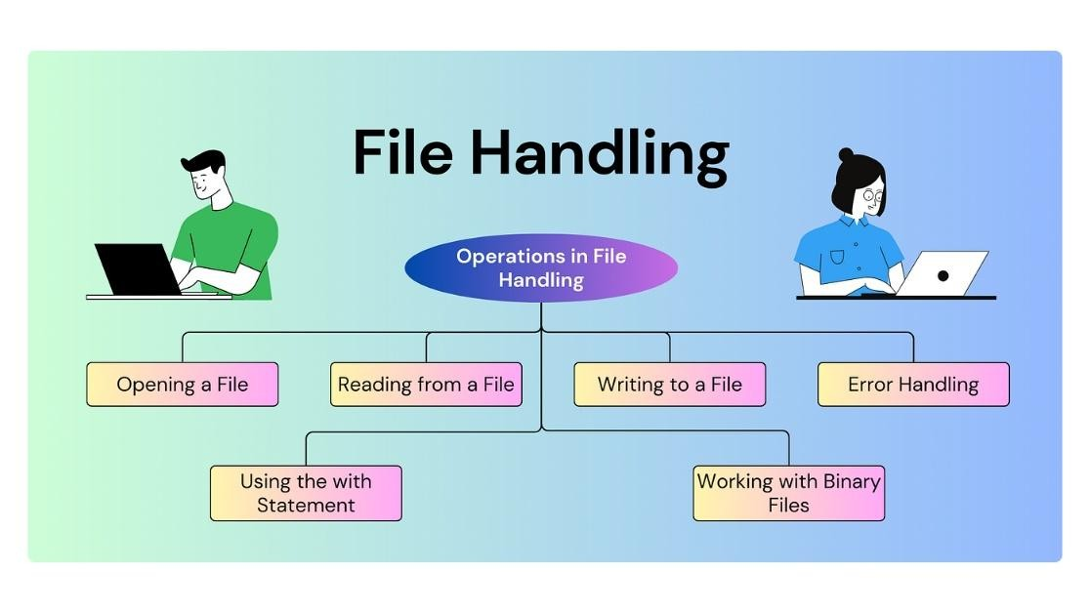

File handling
It is used to store data permanently in files and retrieve it when required.
Syntax:
file = open("filename.txt", "mode")
# operations
file.close()
Types of files
- Text files: store data in readable characters
- Binary files: store data in binary (0s and 1s) used for images, videos, executable files
Syntax:
# Text file example
f = open("data.txt", "w")
# Binary file example
f = open("image.jpg", "rb")

opening a file
The open() function is used to open a file
There are some modes:
- "r" → Read (default)
- "w" → Write (creates/overwrites file)
- "a" → Append
- "rb" / "wb" → Read/Write in binary mode
- "r+" → Read & Write
Syntax:
f = open("data.txt", "r") # read mode
f = open("data.txt", "w") # write mode
f = open("data.txt", "a") # append mode
f = open("image.jpg", "rb") # binary read mode

closing file
closing file ensures that all system resources are freed and data is properly saved it use close() method.
Syntax:
f = open("data.txt", "r")
# file operations
f.close()

Access Modes of File

There are different modes of file in which it can be opened
A File can be opened in two modes:
1. Text Mode
2. Binary Mode
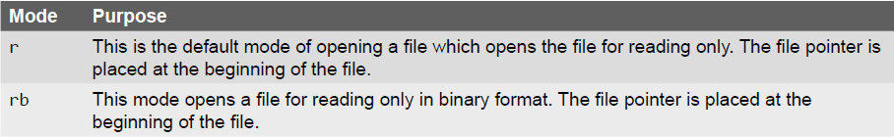
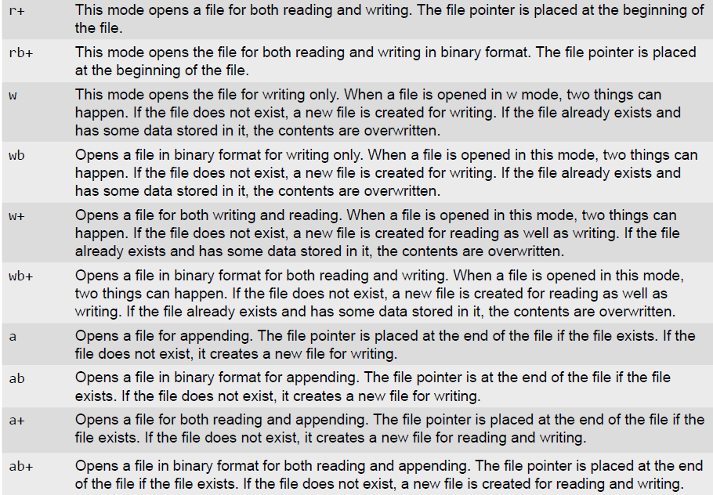

Attributes of File Object

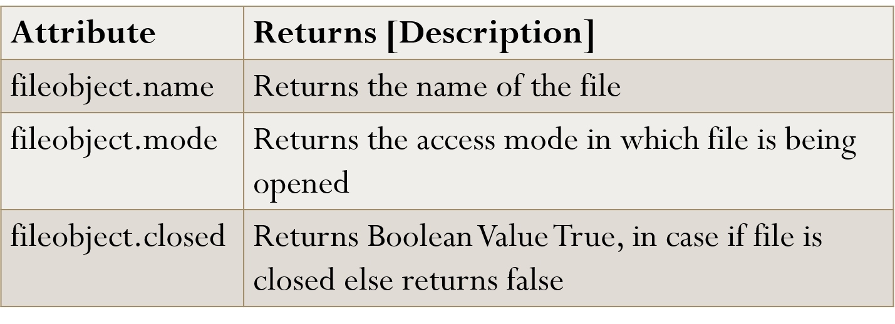

Reading from a file
read() method is used to read a string from an already opened file data from the file.
Methods:
- read() → Reads entire file
- read(n) → Reads first n characters
- readline() → Reads one line
- readlines() → Reads all lines as a list
Syntax:
f = open("data.txt", "r")
print(f.read()) # read entire file
print(f.read(10)) # read first 10 chars
print(f.readline()) # read one line
print(f.readlines()) # read all lines into list
f.close()

Writing to a file
write() are used to write data to files
Methods:
- write("text") → Writes string to file
- writelines(list) → Writes multiple lines
Syntax:
f = open("data.txt", "w")
f.write("Hello, World!\n")
f.writelines(["Line 1\n", "Line 2\n"])
f.close()

Append mode
once you stored data in a file you can always open that file again to write more data.
Syntax:
fileobject.open(“filename”,”a”)

Python File Methods
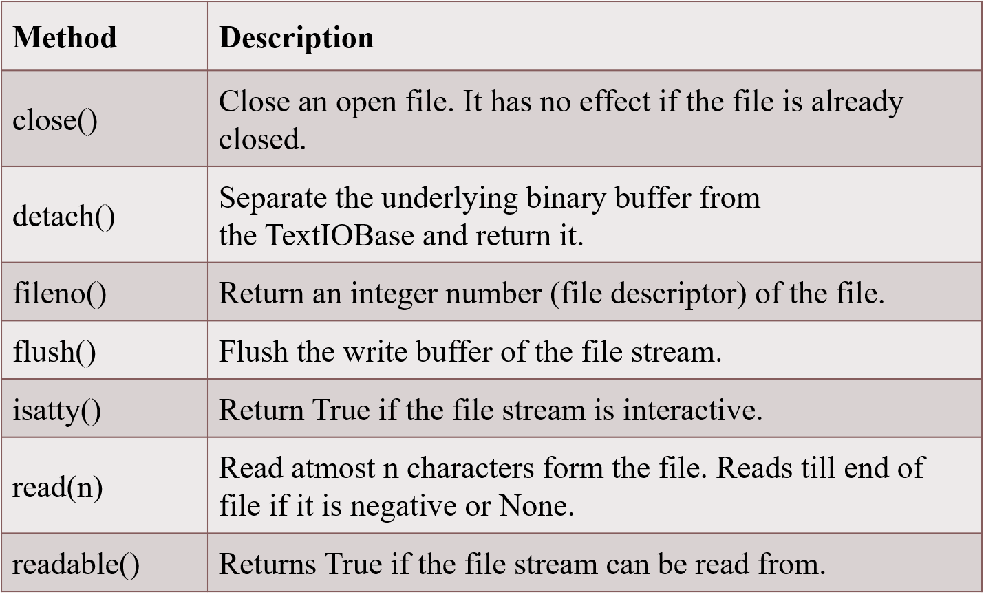
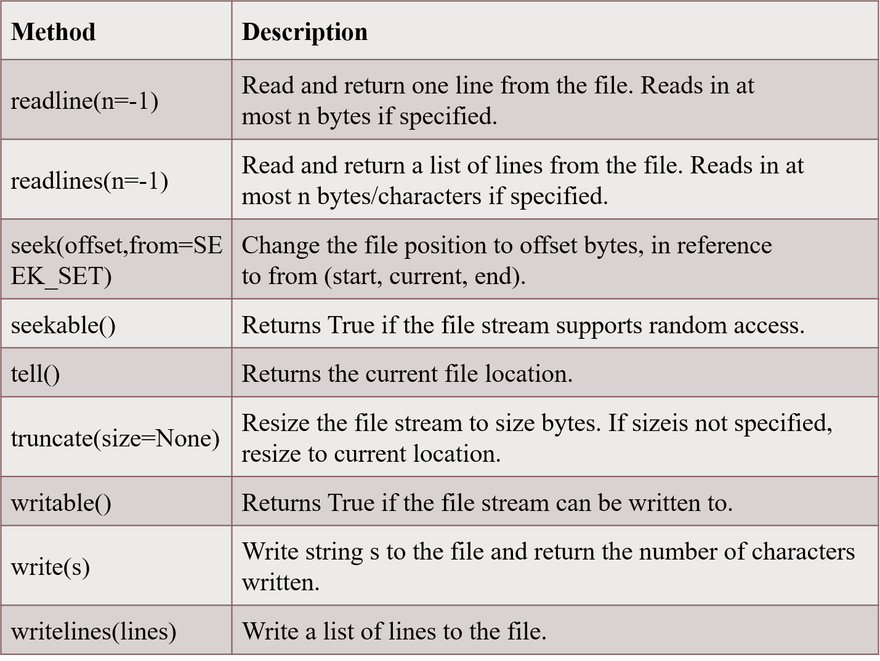

Directory method
os.getcwd()- returns the path of the current working directory
Syntax:
import os
print(os.getcwd())
os.chdir(path)- changes the current working directory

Methods from the os Module
- os.path.split(path) : It accepts a file path and returns its directory name as well so it is equivalent to using two separate methods os.path.dirname() and os.path.basename()
- os.path.getsize(path) :returns the size of the file specified in the path argument.
- os.listdir(path) : It returns a list of filenames in the specified path.
- os.path.exists(path) :As the name suggests accepts a path as an argument and returns True if the file or folder specified in the path exists and False otherwise.
- os.path.isfile(path) : As the name suggests accepts a path as an argument and returns True if the path specifies a file and False otherwise.
- os.path.isdir(path) :As the name suggests accepts a path as an argument and returns True if the path specifies a folder and False otherwise.

Module-IX
Modules and Packages:

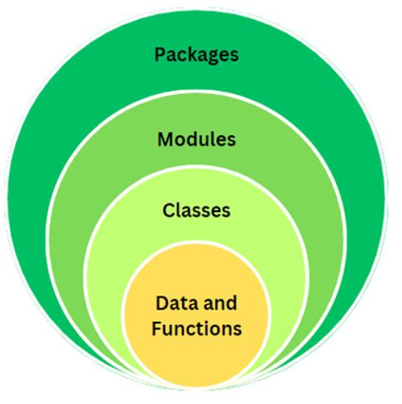

Modules in Python
A module is a file that contains Python code (functions, classes, variables) that can be reused in other programs.
Syntax to import a module:
import module_name

Packages in Python
A package is a collection of modules grouped together in a folder with an __init__.py file. It helps organize large programs.
Syntax:
import package_name.module_name

Built-in Modules
These are modules that come with Python by default (example: math, os, random, datetime).
Syntax Example:
import math
print(math.sqrt(16)) # 4.0
math: Mathematical functions.
- math.sqrt(x): Returns the square root of x.
- math.factorial(x): Returns the factorial of x.
- math.pi: Returns the value of π.
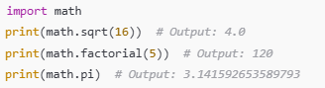
os: Operating system interactions
- os.getcwd(): Returns the current working directory
- os.listdir(path): Lists files and directories in a specified path.
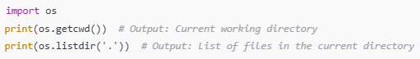

random: Generating random numbers
- random.randint(a, b): Returns a random integer between a and b
- random.choice(sequence): Returns a random element from a sequence.
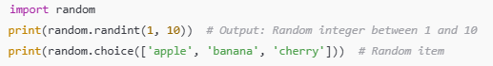
datetime: Date and time handling
- datetime.now(): Returns the current date and time
- datetime.strptime(): Parses a string to a datetime object
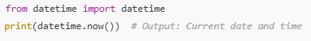

User-Defined Modules
A Python file created by the user with functions, classes, or variables that can be reused in other programs.
Syntax Example:
File: mymodule.py
def greet(name):
return f"Hello {name}"
Main file:
import mymodule
print(mymodule.greet("Manasa"))

Array Math (NumPy)
NumPy allows performing mathematical operations on arrays easily.
Syntax:
import numpy as np
arr1 = np.array([1, 2, 3])
arr2 = np.array([4, 5, 6])
print(arr1 + arr2) # [5 7 9]

Data Types in NumPy
NumPy arrays have specific data types (int32, float64, complex, etc.).
Syntax:
import numpy as np
arr = np.array([1.5, 2.7, 3.2], dtype='float32')
print(arr.dtype) # float32

Broadcasting (NumPy)
A method that allows NumPy to perform operations on arrays of different shapes.
Syntax:
import numpy as np
arr = np.array([1, 2, 3])
print(arr + 5) # [6 7 8]

SciPy
SciPy provides functions for scientific computing. It also has functions for image processing like reading, rotating, and filtering images.
Syntax:
from scipy import ndimage, misc
import matplotlib.pyplot as plt
# Load image
face = misc.face()
plt.imshow(face)
# Rotate image
rotated = ndimage.rotate(face, 45)
plt.imshow(rotated)

Pandas
Pandas is used to handle tabular data using DataFrames. A DataFrame is like a table with rows and columns.
Syntax:
import pandas as pd
data = {'Name': ['A', 'B', 'C'], 'Age': [20, 21, 19]}
df = pd.DataFrame(data)
print(df)

Seaborn
Seaborn is a visualization library built on Matplotlib. It is used to create attractive statistical graphs.
Syntax:
import seaborn as sns
import matplotlib.pyplot as plt
tips = sns.load_dataset("tips")
sns.scatterplot(x="total_bill", y="tip", data=tips)
plt.show()

Module-X
Plotting Graphs in Python

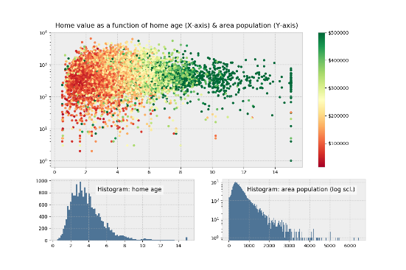

Plotting Graphs in Python (with Matplotlib)
Matplotlib is a powerful library in Python used for creating different types of graphs like line plots, bar graphs, scatter plots, histograms, and pie charts.

Syntax:
import matplotlib.pyplot as plt plt.plot(x, y) # for line plot plt.xlabel("X-axis") # label x-axis plt.ylabel("Y-axis") # label y-axis plt.title("Graph") # title of graph plt.show() # display graph

Plotting - GUI Programming with tkinter
tkinter is the standard Python library for creating Graphical User Interfaces (GUIs). It can also display simple plots when combined with matplotlib or Canvas.
Syntax (basic GUI window):
import tkinter as tk
root = tk.Tk()
root.title("My GUI")
root.geometry("300x200")
label = tk.Label(root, text="Hello GUI")
label.pack()
root.mainloop()

Subplots
Subplots allow us to display multiple graphs in a single figure (window).
Syntax:
import matplotlib.pyplot as plt
fig, axs = plt.subplots(2, 2)
axs[0, 0].plot(x, y)
axs[0, 1].bar(x, y)
axs[1, 0].scatter(x, y)
axs[1, 1].hist(y)
plt.show()

Displaying Images

Methods:
- plt.imshow(image): Displays an image
- plt.colorbar(): Adds a color scale bar for clarity

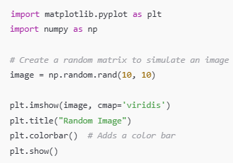
Widgets and Their Methods
Label:
- Label(master, text, font): Create a text label
- pack(): Places the label in the window
Button:
- Button(master, text, command): Creates a button with a command
Entry:
- Entry(master): Creates a text entry box
- get(): Retrieves input
syntax:
import tkinter as tk
# Create main window
root = tk.Tk()
root.title("Widgets Example")
root.geometry("300x200")
# Function for button action
def show_text():
user_input = entry.get() # get text from entry box
label_result.config(text="You typed: " + user_input)

# Label
label = tk.Label(root, text="Enter something:", font=("Arial", 12))
label.pack(pady=5)

# Entry
entry = tk.Entry(root)
entry.pack(pady=5)

# Button
button = tk.Button(root, text="Show", command=show_text)
button.pack(pady=5)

Simple Graphics using Turtle
turtle is a Python module for simple graphics and drawings. It works like moving a pen around on the screen.
Syntax:
import turtle
t = turtle.Turtle()
t.forward(100)
t.left(90)
t.forward(100)
turtle.done()

Customizing the Turtle
turtle graphics allow you to control the pen’s color, shape, speed, and movement to create customized drawings.
Syntax:
import turtle
t = turtle.Turtle()
t.shape("turtle") # change turtle shape
t.color("blue") # pen color
t.pensize(3) # line thickness
t.speed(5) # turtle speed (1-10)
# Draw a square
for i in range(4):
t.forward(100)
t.right(90)
turtle.done()

Bar Charts (Matplotlib)
A bar chart represents categorical data with rectangular bars (heights show values).
Syntax:
import matplotlib.pyplot as plt
x = ["A", "B", "C", "D", "E"]
y = [5, 7, 3, 8, 4]
plt.bar(x, y, color="skyblue", width=0.5, edgecolor="black")
plt.xlabel("Categories")
plt.ylabel("Values")
plt.title("Customized Bar Chart")
plt.show()

Scatter Plot (Matplotlib)
A scatter plot shows the relationship between two sets of data using points.
Syntax:
import matplotlib.pyplot as plt
x = [5, 7, 8, 7, 6, 9, 5]
y = [99, 86, 87, 88, 100, 86, 103]
plt.scatter(x, y, color="red", marker="*", s=100) # s=point size
plt.xlabel("X values")
plt.ylabel("Y values")
plt.title("Customized Scatter Plot")
plt.show()

Histogram (Matplotlib)
A histogram shows the frequency distribution of a dataset (how often values fall into ranges/bins).
Syntax:
import matplotlib.pyplot as plt
data = [22, 87, 5, 43, 56, 73, 55, 54, 11, 20, 51, 5, 79, 31, 27]
plt.hist(data, bins=5, color="green", edgecolor="black") # bins = no. of intervals
plt.xlabel("Value Ranges")
plt.ylabel("Frequency")
plt.title("Customized Histogram")
plt.show()

